News "UFO Latvia"
http://www.ufo.lv/rus/news/ufolats/2012/index.php?51499

20 myths about the "crop circles"

Evgeny Sidorov, Riga, 26.10.2012

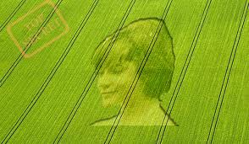
Crop circles haunt earthlings over 30 years. They were found on cereals, canola and potato fields, the fields c vegetables, sugar cane, rice, among snowdrops, grass, thistle, heather, snow, sand, ice and even in the orchards. Many believe that it is one and the same phenomenon, but it is not so! Surprisingly, people are willing to believe in God and the devil, in the ingenious aliens, but do not want to take a simple and logical version - icon people do! Before our eyes, formed a new subculture. Intelligent and educated, shrewd and cautious, and most importantly, a sense of humor and motivation, the young men of the night do landscaping - a new form of art and self-realization! Apparently, people can not live without feeling like there is a miracle, this adds to our being a mystical and sacred meaning!

As research icons increasingly tsareologists (researchers of pictograms) have concluded that these amazing formations are fake. Today among researchers appears in the figure to 95% - the percentage of fake icons, but this fact does not convince anyone! After all, is still about 5%, which give, though small, but hope for a miracle!
In this article, I will make a judgment about these signs from the point of view of common sense. Who wants to, he will be able to add your own sign, which, in his opinion, can definitely prove unearthly reason in the origin of these zamechalnyh formations. I will be glad! My main task - to show you a different, critical and unblinkered look at a phenomenon that is not haunted by many generations of researchers of paranormal phenomena. In this article I will not persuade anyone, but simply will express their criticisms, which in some way relate to the grounds of authenticity * icons.
* Authenticity - property to ensure that the entity or resource identical statements are valid, authentic, genuine accordingly.
That is an authentic icon should have a combination of features which convince us that the icon is a genuine (authentic), and not a counterfeit! Evidence must be neotklonyaemymi and unambiguously interpreted.
But to do this, first of all, you can select features such authenticity that would allow us to answer the question: what are the true icons? This requires at least one original authentic ICONS, from which we can further push off! Only in this case can be distinguished set of features that are not possible (paradoxically) in nature and can not be intentionally create!
And now comes the moment of truth. Of the original and there never was! That is, a body of the signs in the pictograms today is not possible! Then begins tsareologov initiative, which is reduced to a whole list of different systemic and non-systemic symptoms * unusual, though found on the various icons and that more and more mythologized *.
* The sign - a description of the facts, allowing (the existing theory, etc.) to conclude that there are interested in the phenomenon.
* Myth (ancient Greek. Μ ῦ θος) - tale that conveys the way people thought about the world, fiction, fictional story.
Today, researchers identify the major and minor symptoms, the presence of which in their view should confirm the authenticity of the icons. Although in this list there is no agreement among researchers, in fact, such a division is rather arbitrary.
I do not pretend to be exhaustive consideration of authenticity signs icons. Topic that I raise very complex and controversial. And, if you approach it in a strictly scientific, the conversation may end before it even started. After all, everything that is done in parascience tsareologii say the least, very far away from science and scientific methodology.

1. MAIN CHARACTERISTICS AUTHENTICITY PICTOGRAMS
Myth 1.1. In authentic icons show the metal particles
In circles tsareologov considered in the authentic pictographs found tiny particles of magnetite and (or) hematite. Note on the field can always be present particles of different compositions, including and having magnetic properties and getting on the field in different ways, including and falling from space (meteor dust *). Not exclude cases where a similar particles can be taken traces (scale, metal droplets and electrodes) from welding work being done in the field.
* According to scientific data to Earth every day falls 6.5 tons (!) Meteoritic material
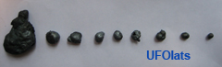
Such small ferromagnetic particles can be found on the pictograms

But in this case, we are dealing with a non-systemic facts, snatched out of context, and do not have any relation to icons. Tell me, you've seen a lot of, for example, diagrams of the density distribution of these hypothetical particles on the icon ? Such information, alas, no! Conclusion : Unfortunately, this is another myth that is duplicated from article to article, and who lacked a solid scientific foundation.
Myth 1.2. In all authentic icons, anomalous strain stems cereals without requiring a physical break
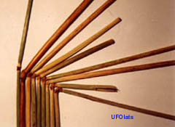
Angle abnormal deformation of stems can reach over 110 degrees!
This fact of tsareologov is the most obvious and clear sign of the authenticity of the icons, which affects their imagination. But is a unique phenomenon? Any more or less observant researcher can detect such stems with abnormal strain on a normal field, by the way, not only on the grass, but even on the grass! Such a deformation, in short - the result fototropicheskoy plant response. Detail the mechanism of abnormal deformation will be given in a separate article. It's worth it for some reason, at the same time, researchers shamefully silent on the icons on the rapeseed fields, where all stems ruthlessly crushed.
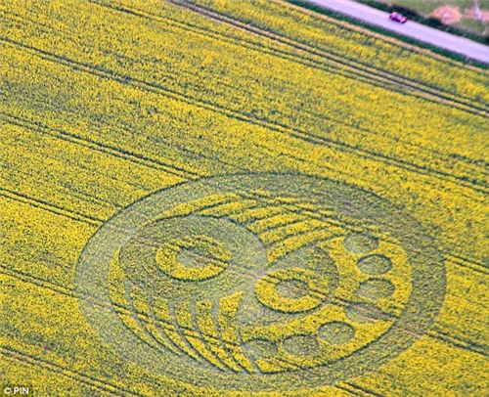
The first crop circle in 2012 was seen by rapeseed field in the Wiltshire (UK). Here the anomalous deformation are not talking
Conclusion : abnormal strain stems - very normal and natural stage (without losing their zhiznesosobnosti) in the development of cereals which, for one reason or another, were placed on the ground!
Myth 1.3. Explosive nature of the destruction sites stems indicates exposure to microwave radiation
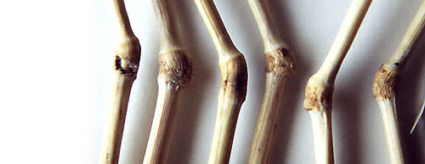
Stalks of cereals with "explosive" destruction sites
In addition to the abnormal deformation of stems of plants of great interest and explosive rupture sites stems of cereals. The researchers hypothesized that a possible explosive rupture when exposed to microwave radiation to the nodes of the stems. It is known that the nodes of stems the highest concentrations of moisture. Provides similar explosive rupture the example of temperature gap of maize.
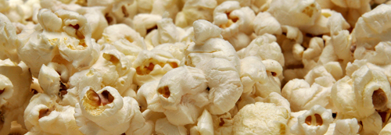
Explosive (temperature) disclosure corn kernels
That cast doubt on the reality of this mechanism in the case of cereals?
• First, the fact that a catastrophic (explosive) damage sites stems from the effects of microwave radiation is not confirmed experimentally in the laboratory. This is verified by several investigators.
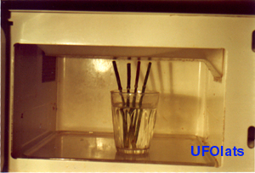
Fragment of the experiment with the microwave radiation on the stems of cereals

• Second, if we assume a similar exposure cereal fields necessary to achieve the desired effect, power (thermal effect should result in boiling water at the sites and their further steboey explosive destruction!), it must be recognized and the accompanying consequence - the icon should be everywhere " fried "insects, which in any field is set! But of this, researchers prefer to remain silent, apparently, for the simple reason that such a massive auto of insects in the field is not! br> In addition, visitors can independently calculate the output power of the original space-based maser, which is necessary to create the desired effect on the Earth's surface. The result will surprise you.
• Third, the paper gives some photos of similar broken catch, but not a word is said about the mass of such a phenomenon and given the correct data on the distribution of such catastrophic damage sites throughout the area icons
• Fourth, researchers ignore the fact that such breaks nodes can always be found in any field, which confirms the fact that this is a common (but not universal) phenomenon on cereal boxes, which, most likely, due to the peculiarities of a particular plant or indicates chemical or biological cause such damage nodes of the stem.
conclusion : the presence of individual nodes on the stems of the destroyed icons can not be conclusive scientific evidence of the hypothetical effects of microwave radiation on cereals.

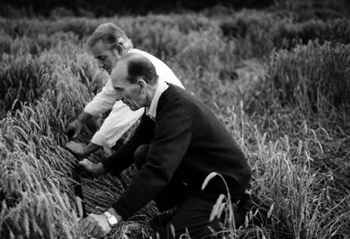
Myth 1.4. The complex shape of authentic icons clearly indicates their non-human origin in September 1991, the population of Great Britain David Cherley and Douglas Bower confessed to creating community. According to them, the first pattern they did in 1978, inspired by the images of tracks left on the grain fields of agricultural machinery.

The first people to work out methods laying ears were UK residents Cherley David and Douglas Bower, where so far found about 95% of all the icons. It's about what you do not say?
The complexity of the crop circles rapidly become complicated around since 1990 XX century, when there was a qualitative leap - from simple circles to complex icons. Apparently, this kind of art (kind of landscaping) interested in advanced youth! It is believed that with the complexity of the geometry is complicated pictograms and information transmitted to mankind unknown authors. But is it?
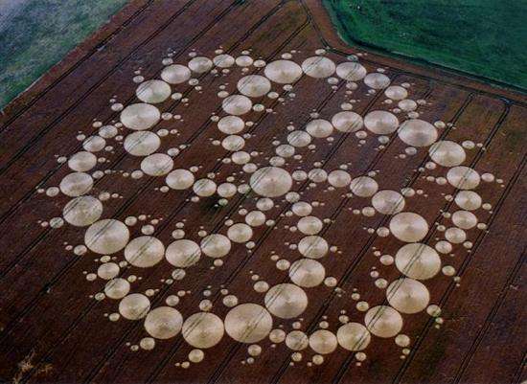
Icons can include more than a dozen items
Let's take an unbiased look at the situation? Unless there is one fundamental reason, which would not allow a group of people to create an icon of any level of complexity? Alas, there is no such reason. And with that, we have to agree! Obviously, the question here is only in the preliminary training, skills, time availability, and appropriate technology, and, of course, (until a certain time) conspiracy.
conclusion : the difficulty drawing icons can be a sign of extraterrestrial origin. With adequate resources, you can create an icon of any complexity.

Myth 1.5. On authentic icons recorded magnetic (electromagnetic, electrostatic, etc.) anomalies in this case requires explanation. Each point of the surrounding area is characterized by the values ​​of the parameters of the magnetic, electromagnetic, electrostatic, radiation, gravity and other fields. Moreover, these values ​​are not any fixed values ​​, and are a function of many external parameters, t.ch and time. example, the level of gamma-radiation is determined by superposition of three potential sources of radiation associated with:
- natural radioactivity of the underlying rocks,
- natural radioactivity associated with cosmic rays and solar radiation (including with solar flares)
- artificial man-made contamination radoaktivnym ground. Integral gamma background value at a given point can float in a fairly large range. This can be seen in gamma radiation dosimeter, which measures the exposure dose at a given point. I have had to watch as the value can vary from about 6 to about 22 mR / h at one point at different times. Obviously, for correct measurement necessary to average values ​​of several measurements at different points in the study information. Only in this case the measurements are correct and trustworthy. If not desired can be easily mistaken for the real, which is often seen in research icons.
Conclusion : there is currently no valid data on anomalous values ​​suschestovanii any fields within the thumbnails. Therefore we can not say that this is a sign of the authenticity of the icons.
Myth 1.6. On authentic icons stalks arranged in the form of "pigtails" that confirms the ethereal nature of their appearance the study of icons often pay attention to the direction in stems. Recorded as left-and right-handed direction in placing the stems in circular element icon. But sometimes it can be seen crossing the stems, layering in their styling. Of course, this is not a form of "pigtails" and overlay layers. Is there a reasonable explanation for this arrangement stems? Will express their views on this interesting effect. easiest (1) a method such styling - is deliberately consistent styling. First, a single band (at an angle to the center line), and then similarly (but towards) the other bands. Styling will remind "Christmas tree." This so-called quick way to create a "pigtail-tree" on the icon.
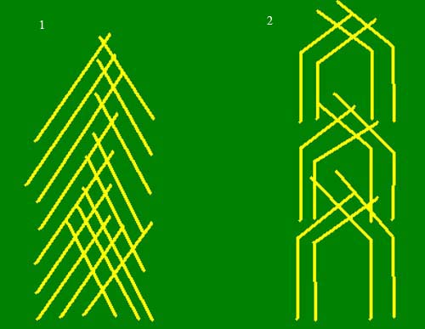
Two simple variants of possible entanglements packed stems of cereals.
The second method (2) is based on the premise that the stems are not laid once and frozen formation, as Plants are living organisms, which keep their fototropicheskie reaction. And the directions fototropicheskoy deformation directly related to the features and direction of the lodging (laying) of the stem. Thus, the possible counter (weaving) fototropicheskaya strain stems, which after some time (chasy!) can lead to entanglement stems on the icon *. * general effect fototropicheskoy reaction stacked stems can present interesting surprises. Icon on Malpilsskoy we faced with such a feature, which has not yet been confirmed by other researchers, but she was confident we fixed. Read more in the article Malpilsskaya icon .
Conclusion : fototropicheskaya reaction stacked stems - real biophysical phenomenon that occurs on the icons, which can create intricate designs ("twist", "pigtails", "tree", etc.) stems.

Myth 1.7 . Grain authentic icons are oppressed germination researchers - tsareologi argue that seeds polegshih in the icon stems are oppressed germination. How can you comment on this conclusion? Stems that have been flattened (the reason for this yet keep silent) can not be normally developing as disrupt their normal vegetative development, changing the power of the stem, light conditions, etc. Many forces in the stem out to restore normalcy. All this ultimately inhibits the normal development of the plant, which is reflected in the offspring - the seeds. Our experiment with relative germination of seeds taken from normal areas of the field and icons, confirms the oppressed germination and further development of seeds taken from the icon. A similar effect is observed in all cases in which a more or less prejudiced the normal development of the plant is important from what is not an external factor.
Conclusion : a sign of a necessary, but not enough to consider it a sign of the authenticity of the icons.
Myth 1.9. Authentic icons are perfect geometric shape, which confirms their ethereal nature of authentic icons have hit their perfection, beauty, complete form, harmony. It is believed that such ideal figures in the fields people can not create. But is perfect geometry of these strange figures? should be noted, I have never seen articles that are strictly and properly examining the geometry of the icon : the equality of corresponding angles, distances, intervals, and other elements. If discard euphoria and an open mind to look at the icons and critical (in terms of the goodness of their geometry), they will become visible nuances that break the myth of the ideal geometrical shape of these formations. It turns out that the corners do not match, the two sides are not equal, and many other hidden from the sight of the nuances. In addition, there are even more remarkable accuracy, the so-called blob - when the perfect geometric figure and harmonious disfigure ridiculous inclusions in the form of one or more fatty points both inside and outside of the formation.
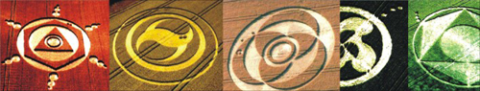
Blots on the icon, as a small mole on the face of pure beauty
Each icon has a lot of similar inconsistencies: lines, corners, blobs, which destroy the myth of the ideal perfect icons. A similar error in the picture I found on Malpilsskoy icon , the place and nature of the situation that few people know. Moreover, apart from blots and inconsistencies lines are detected and additional drawings of the original icon, when available form with time added additional fragments. But unfinished icons I have not met, but their existence is logical. Can researchers - tsareologi have information on pending icons? In that case, I will be grateful for the information! Maybe those who draw their very seriously preparing (which I do not doubt it) to work, and always brought his case to a logical conclusion? What do inconsistencies, blots and other discrepancies? First of all, the fact that the icons are not, as some believe, a product of man-made or instrumental effects. They do not draw from space superpower maser to a predetermined pattern (matrix or program) believes, for example, a researcher from Krasnoyarsk - theorist Paul Poluyan. Icons - a product of those who can make mistakes, change and refine their decision. This is - the product of man!
Conclusion : the myth of the ideal form of a false icon. Without exception, all the icons are inconsistencies, blots, additional drawings, ie errors in their geometric form. Icons do not have perfect geometric shape.

Myth 1.10. Icons are formed on tectonic faults and tend to "kuchkovatsya" to the ancient shrines and other historical monuments. Sometimes we hear that the icons are in places where there are tectonic faults, in which the cause of the icons associated with the telluric currents, energy and emissions underground etc. As you know, most of the icons are concentrated in England (~ 90%) in a place called Wiltshire ((Wiltshire). But bad luck, that in England there is no hint of the powerful tectonic faults, which can be determined by looking at the Map of tectonic faults of our planet!
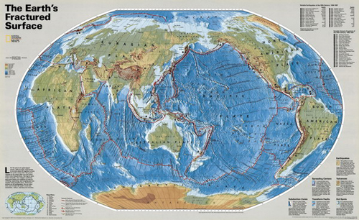
There is no correlation between the appearance of the icons in some places and places with tectonic fractures
Conversely, there is no icon there where there are powerful tectonic faults, such as Kamchatka, Japan, New Zealand. further I say is meaningless. Any rational and critical thinking person will understand that the tectonic faults icons have nothing. As well as to the ancient shrines and other historical monuments. For example, there are no reports about the ancient pictographs Arkaim in Russia, but there is in the area of the ancient sites such as Stonehenge, Avebury and Silbury Hill, bred in northern England, where it is and comes ~ 90% of information on icons, which is banal fake! Clearly, this artificially attracted by cause-and-effect relationship has nothing to do with science.
conclusion : there is no reason to believe that the icons are formed in areas of tectonic faults and tend to the sacred monuments of antiquity.
Myth 1.11. In the geometrical icons hidden complex mathematical laws Researchers icons celebrate not only the complex structure drawing formations, but the information content of the icons. Of course, much depends on the subjective interpretation. Indeed, one researcher can see a simple circle, and the other private information about planets in the solar system, or a warning to humanity of the impending disaster. There are icons depicting animals, insects, birds, plants, people, and even an alien!
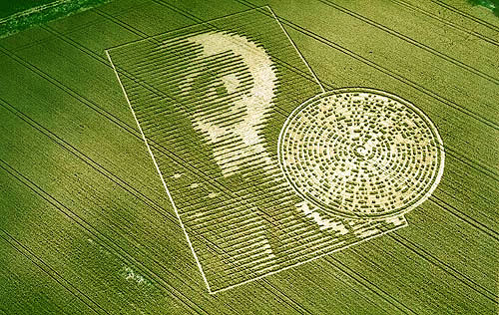
August 15, 2002 on the field in Krebvude in Spassholte Hampshire, England, was applied to the face image icon humanoid

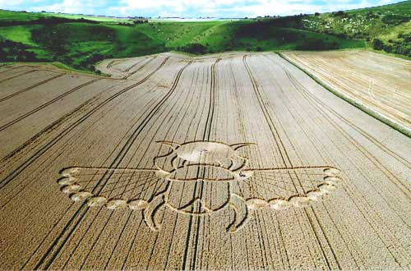
Icon "scarab beetle"
I think few readers will doubt that these primitive in its information content created by people icons. Obviously this is the work of creative people! And notice what the high level of performance, these (primitive content) icon! The huge range of icons there are the so-called advanced icons that use extremely complex forms of Euclidean geometry, Fibonacci numbers, the golden ratio, fractals, etc. In the pictograms can be encoded information on physical constants, the astronomical data of the solar system, the Earth, etc. Really advanced icon thing (I almost said "hands") extraterrestrial intelligence?
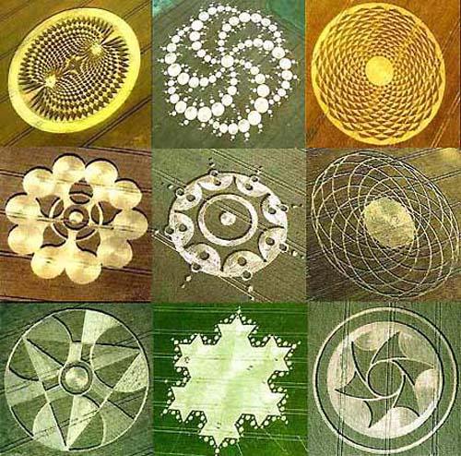
Complex icons listed in the journal "Courier" 21/10/2002, Brooklyn, New York, N44
And what's the difference in creating a harmonious pattern "Beetle", which, incidentally, also contains a proportion of the golden section, and any other advanced formation? In terms of creation, "Beetle", perhaps it would be more difficult in the formation of a "solar system with a planet Nibiru." And why did you decide that the aliens have the same notation as humans? Clearly, in our icons reflected, the human world, experience, mathematical concepts and logic. For information in them did not contain extraterrestrial! Hence the obvious fact - advanced icon Soda makers with advanced mathematical turn of mind, but with a limited imagination.
conclusion : primitive and advanced icon does in terms of technology and the creation of the same. Differences affect only the information content of the latter. This fact suggests that the creators are genuine people with a mathematical turn of mind.

Myth 1.12. The icons are created in a very short time, believed that the icon of any complexity are formed very quickly, within minutes. But Okuda follow this lead? We have to admit that this opinion is based solely on the subjective testimony of the individual and does not have an independent and, especially, objective evidence. What else calls into question the validity of the thesis of the rapid emergence of icons? The fact that the icons (as indicated by the researchers) have a pronounced deformation stems stems. And it suggests that, for this strain fototropicheskoy stems and, given the speed fototropicheskoy reaction was to take at least a few days! After fotopropicheskaya reaction has a finite speed, measured in units of "angle strain for Edineţ time." This reaction rate stems strongly dependent on weather conditions (illumination), humidity stem varieties of grain (corn resistant to lodging or not), etc. That is, Knowing the angle strain stems. * can calculate the time between discovery and lodging icon! more this effect will be presented in a separate article. * in this case we are talking about the stems with anomalous strain output : classic icons with abnormal deformation of stems (without damage) may form at least a few days! Other icons (with broken stems) may well be formed during the actual laying of the stems, ie a few hours.
2. Secondary feature AUTHENTICITY PICTOGRAMS
Myth 2.1. "Crop Circles" are known from ancient times
to the present case there is a substitution of concepts. The fact that the formation of the fields may have a completely different nature. Sure, for our ancestors, all the formations in the fields were "witches circles" inspiring fear and terror with their uniqueness! Therefore incorrect to assume that the "crop circles" (in the sense that today is embedded in the concept) - the phenomenon of old.
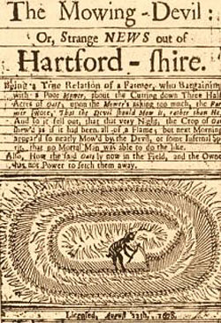
English pamphlet in 1678 entitled «Mowing-Devil» ("devil-mower")
Conclusion : a statement is false. Various societies in the fields have long been known. All of them are of different nature . There is no reason all the formations were reduced to one concept that dominates the minds of researchers.
Myth 2.2. The pictogram registered high percentage breakdown of electronic equipment syndrome "broken camera" or "nevklyuchayuscheysya camera" - is common in the pictogram. With that face all who study crop circles. The mobile phone does not work, the camera, the radio. It is said that after visiting the community ceased to operate a bank card and electronic key from a hotel room! Compasses begin to lie, the battery will discharge rapidly, and the devices start to act up aircraft when flying over the formation. How these observations are correct, it is not given here wishful thinking? hardware failure - frequent occurrence, and in a familiar environment, this event we did not cause much surprise. Electronics failure was, is, and will at all times their actual use. Experts know that the electronics - the science of contacts. Any technical failure of equipment associated with a specific technical reason that you can set, if it ... engaged professionally! But the problem is just that no one wants to diagnose the failure of its equipment. Judgments are carried superficial euphoria and under pressure from his colleagues. In this situation, critical thinking, most people locked. yuboy little bit and usually clear failure (which does not cause problems at home) in the equipment, immediately refers to the influence of icons (its anomalous energy-fields) on the performance of the equipment. But any electronics will always find a reasonable explanation for the failure, as Each failure has a material cause. The situation is similar to the psychological effect of "black cat" when repeated her appearance does not cause problems as long as the one-off does not work out and poor connection "cat-event."
Conclusion : Currently there is not any statistics that would show an increase percentage failure of electronic equipment in the pictograms. No valid data on the physical impact (with the establishment of the exact cause-effect relationship) icon on the performance of electronic outfit of. Uncoordinated, non-system and disposable equipment failures have been and always will be, regardless of whether you're on the icon or not.

Myth 2.3. In authentic icons distorts time What does it mean to change the course of time? Category of time is very complex concept, which has little to do with the used in everyday life the concept of the reference time. There is still no generally accepted scientific understanding of the nature of time. As the researchers have in mind, let's change the time on the icon? If there is a view ahead or behind standard time registration systems of time (hours), where intelligible statistics and analysis of these measurements? Do not! If there is a change in view of the subjective feeling of the passage of time, then it is even more so, can not be reliably established facts, as requires significant independent audits. Therefore, temporary effects on the icons are artificial - to pull and scientifically unsubstantiated myths.
Conclusion : today there is no proper information about temporary effects, allegedly observed by the pictogram. The available information is random and untested and can not be the basis for this conclusion.

Myth 2.4. On authentic icons registered "glowing balls", responsible for the fields of art in 1996 as documented explanation of how the fields appear in the complex pictograms. Sensational video was taken August 11, 1996 in the town of Oliver Castle (England). Video camera recorded the flight of over three pairs of glowing balls! As a result, literally 2 seconds plants subsided, creating a beautiful icon, consisting of the 13 laps!
Such sensational footage could not leave anyone indifferent. Analysis of the film joined renowned experts. The following quote to a consultant for NASA video photographic analysis, an expert on computer analysis Diletozzo Jim: "After careful - frame by frame - computer analysis we drew attention to the fact that during the movement of the balls for them is the energy of the vortex trail ... grains were set in motion after the ball appeared above them. Each "circle" comes about through the spiral movement of energy going after the flying objects ... Analyzing data from the most upper videotape, ie signs that are visible on the film can be conclusions about that ... This film was made ​​without the use of a computer ... I believe that there is no animator, who would be able to create such a film ... I do not find any trace of falsification of data frames . Other independent experts have a similar conclusion: the film recorded a real event. "
It seems they - those who draw these strange figures, but ... it takes several years, and the message that the video - fake, which involved the manufacture of one John Veyb (John Wabe) - one of the partners of the studio editing and animation "First Cut Studios" (Bristol, UK). Under pressure from the evidence (or other arguments?) Veyb admitted that the video was produced by the studio. Sensation in the end proved a pacifier! not withstand serious analysis and other photos, which recorded some "glowing education." Alas, in this case the luminous formations are stray light from the glare of fine particles (of which in the field is very much) in the light of the flash. In this, as well, and in most cases, we are dealing with an incorrect interpretation of the known phenomena (stray light).
Conclusion : it must be noted that at present there is no reliable infomatsii the existence of luminous spheres responsible for the art in the field.
Myth 2.5. Recorded by the pictogram "abnormal sounds" Some argue that the icons are sometimes detected abnormal sounds (noises, whistles, etc.). Unfortunately, no "abnormal sound" and was not provided for review and has not been published. Certain statements remain at "someone heard something." Therefore, to discuss the nature of these sounds no reason. Rather, we are dealing with the myth of clean water, which is devoid of any serious scientific basis.
Conclusion : This feature invalid and can not determine the authenticity of the icons.
Myth 2.6. People on authentic icons have unusual physiological experiences Those who have been in the authentic icons was a strong headache, severe nausea, a metallic taste in the mouth, sudden hunger, confusion, anxiety, fear, euphoria comprehensive. no doubt, will be similar to the response and to capture the imagination of other formations that create people. Example - the witches' circle. Do not you think it would be strange if the people who come on the icon, and which they believe is the "information signal aliens" would be indifferent to it? Sure, attendance icon accompanies euphoria, elation, joy touching something mysterious , extraterrestrial. People are actively discussing the formation, one meditates, one conducts research. The fact is that in this time, people are very active and many participants inevitably increases the pressure! And then like all other people, someone from headache and nauseated even starts. Someone from an overabundance of feelings and emotions falls into a stupor from touching the secret and he begins to fear "as if something happens." It's a signal from another mind ! And the fact that many are hungry, too, is not surprising, as "enthusiastic hours do not notice." People are all different and, of course, their reaction may be different.
Conclusion : certainly physiological experiences and icons are the place to be, but they are relevant only to the individual reactions of people and their interpretation of the nature of the appearance of the formation. And nothing more.
Myth 2.7. Water, which visited the icon, improves their useful properties This is something of "chumakovschiny" having a rather relevant to psychiatry, not physics. Today there is no correct experiment confirming the change of physico-chemical properties of the water, having been on the icon and the last independent scientific scrutiny.
Conclusion : the myth of clean water that does not have serious grounds.
Myth 2.8. Pictograms avoid animals. believed that animals avoid places icons, but no mention of the presence of insects on the icons! If you look nice observer on the ground, you will see that the icon for full of life of insects! Why do large animals do not go to the icon? Does that even a rational basis? And it turns out there is that wild animals are very cautious creatures and they will not go back to where they will be in the open in plain sight, without cover. known that the icons can be significant, so the fields produce large open areas. Animals are afraid to go to these open areas of the field! That's all! And it does not related to the icon. Everything is quite rational and understandable!
Conclusion : the fact of avoiding animal icon is taking place, but it is associated with behavioral traits (care) of the animals in the open and can not be a sign of the authenticity of the icons.
Instead of a conclusion
Undoubtedly, the creation of icons is a new Landscape Art, gaining strength among the advanced youth. For mission-minded people nature icons, technology of their production - the question is settled. But despite the clarity of principle, there remain questions that inquiring minds want to get the answers. Scope of this article does not allow me to answer these questions, but any reader can think about them and to express their views in the comments to this article, or on FB . These are:
• Why not observed incomplete ("meat") icons? It is obvious that sooner or later artists could frighten,
• Do not quite understand the nature of the country stems strain discovered on Malpilsskoy icon. So far there is no evidence of this effect on independent research and this is despite the fact that I have repeatedly reported on this on UFO forums. Biologists also nothing good can not tell. Once again draw the attention of researchers icons to record not only the vectors lodging stalks, and vectors of deformation stems

• Are there any icons in fields where there are no technological band?

• What motivation artists
Yevgeny Sidorov
Riga
26.10.2012

